CSC 3210

Computer Organization and Programming

Lab 4

Answer Sheet

Student Name: Tracy Michaels

Section: 018

Debug through each line of code.

Take screenshot that includes code and register window.

Record the register content.

and explain the register contents.

Line number: 15

Instruction: mov al, 245

Register values: EAX = 000000F5

Screenshot: 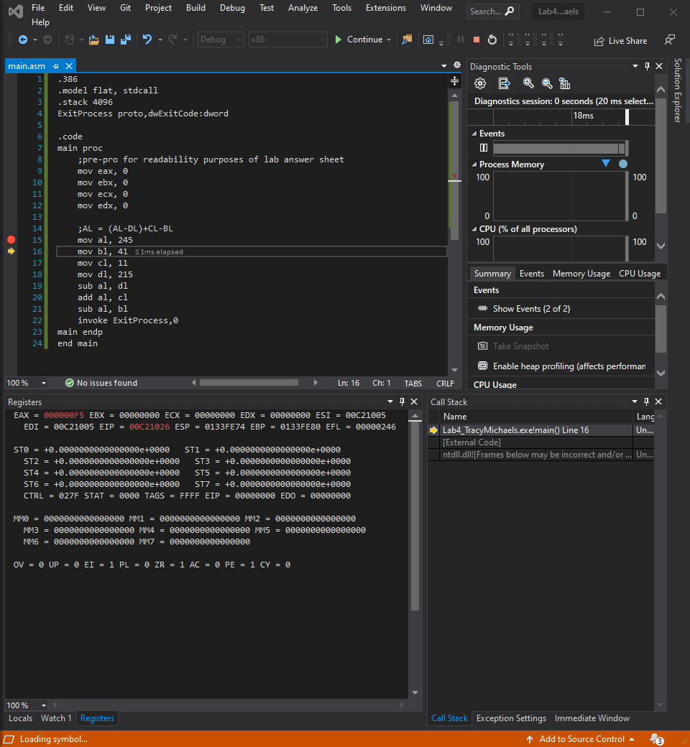

Explanation: moves the decimal value 245 (hex F5) into the AL portion of the EAX register,

Line number: 16

Instruction: mov bl, 41

Register values: EBX = 00000029

Screenshot: 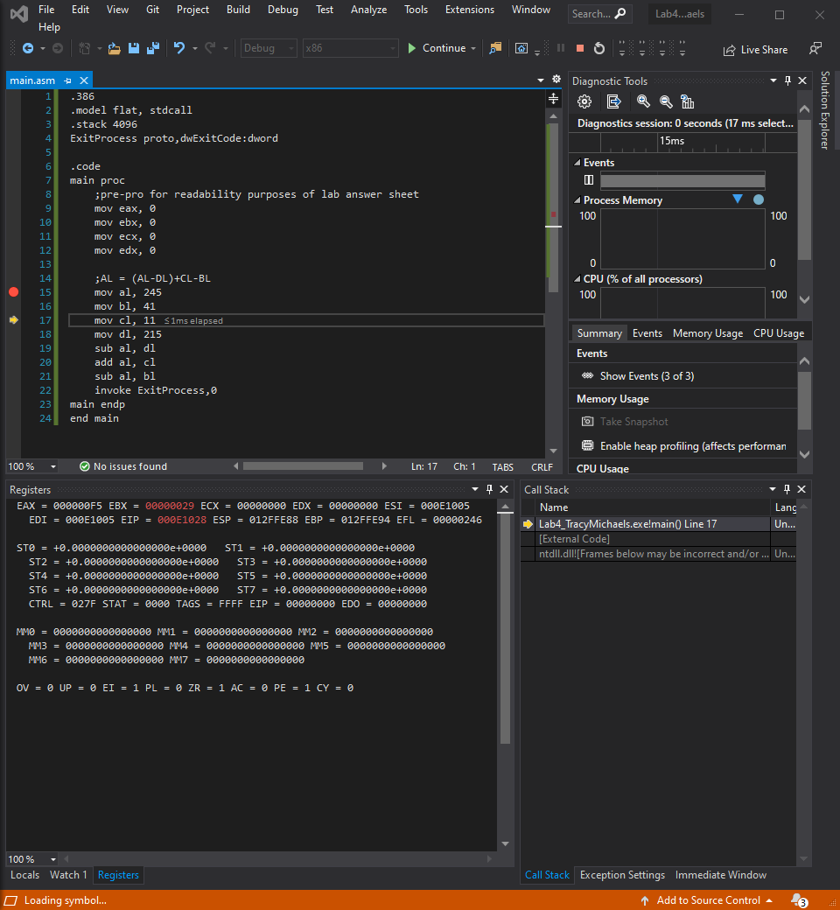

Explanation: move the decimal value 41 (hex 29) into the BL portion of the EBX register

Line number: 17

Instruction: mov cl, 11

Register values: ECX = 0000000B

Screenshot: 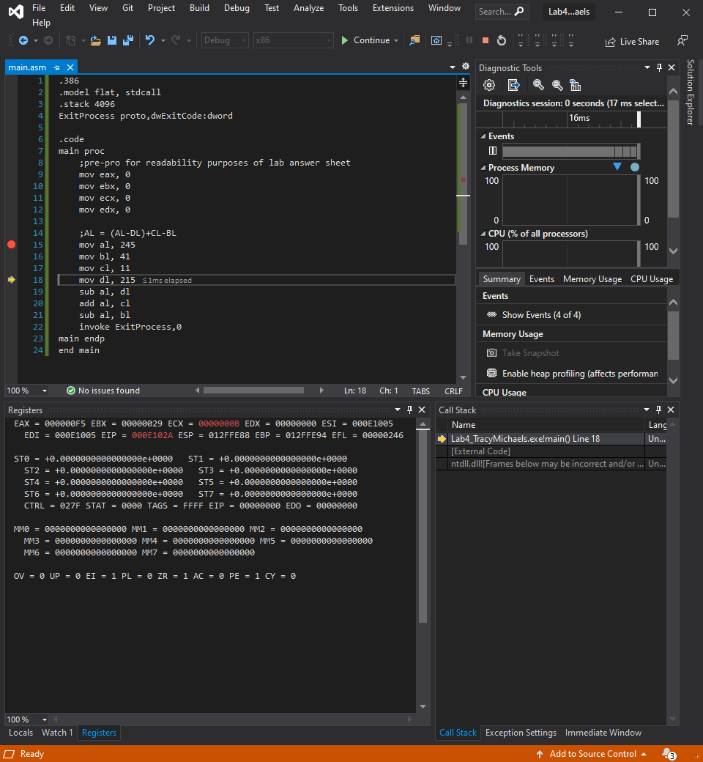

Explanation: move the decimal value 11 (hex B) into the CL portion of the ECX register

Line number: 18

Instruction: mov dl, 215

Register values: EDX = 000000D7

Screenshot: 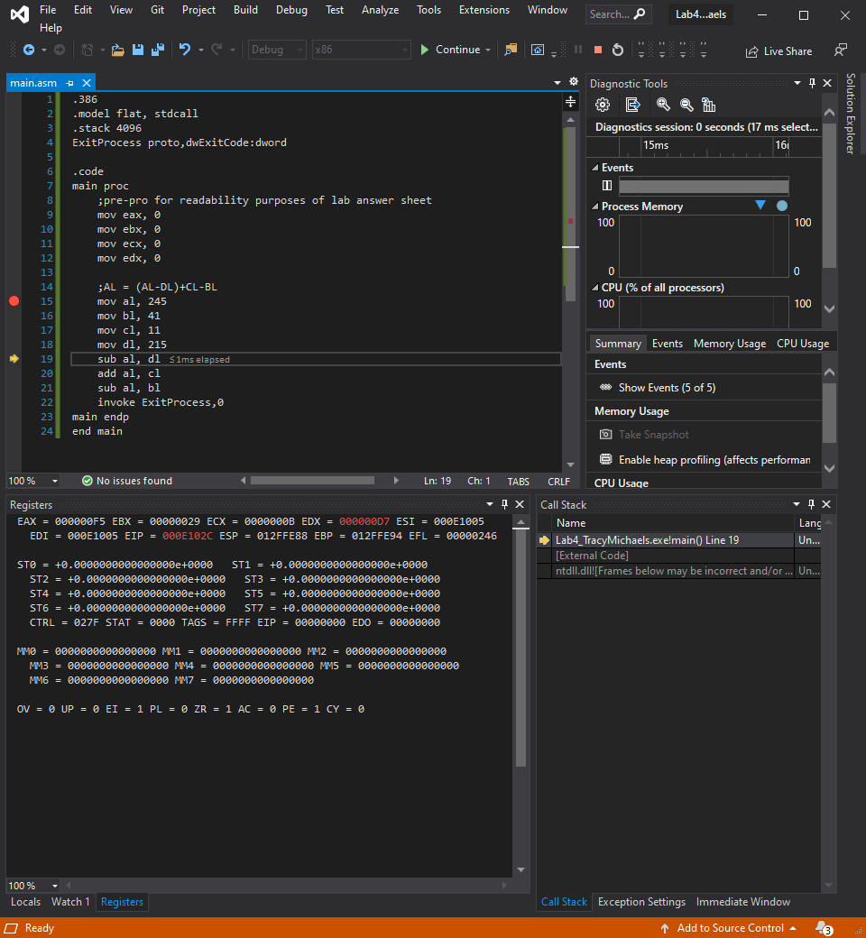

Explanation: move the decimal value 215 (hex D7) into the DL portion of the EDX register

Line number: 19

Instruction: sub al, dl

Register values: EAX = 0000001E

Screenshot: 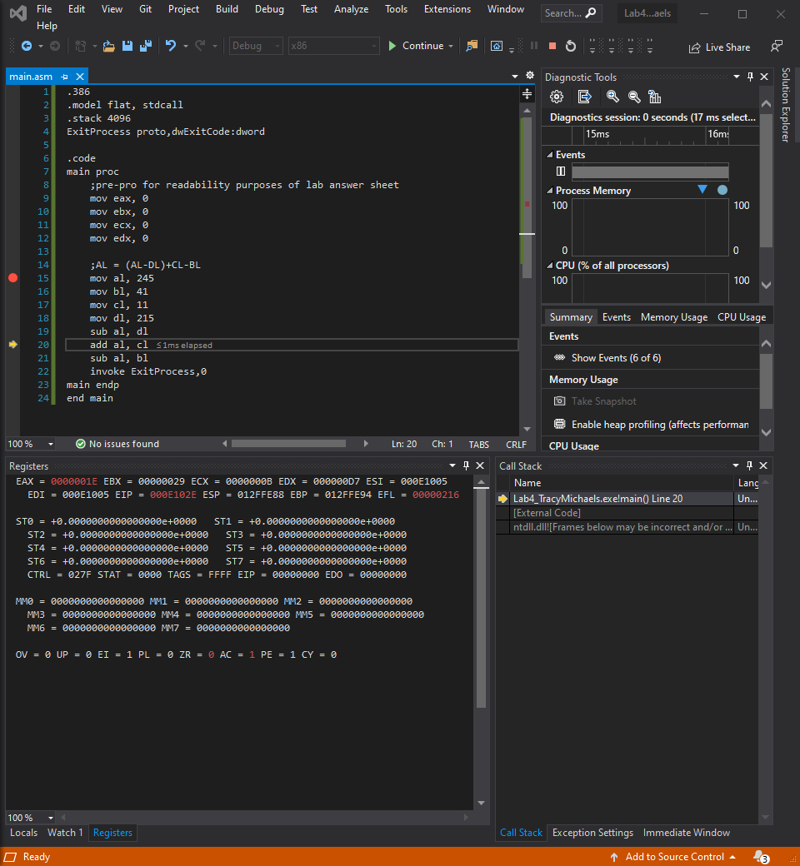

Explanation: subtract the value stored in DL from stored in AL and store result in AL (dec 245 – 215) = 30 which is 1E in hex

Line number: 20

Instruction: add al, cl

Register values: EAX = 00000029

Screenshot: 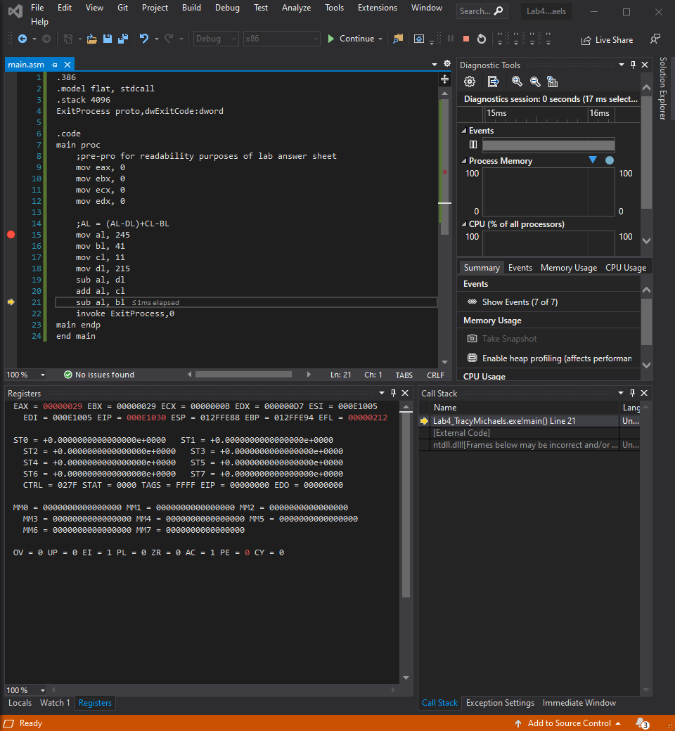

Explanation: add the value stored in CL to the value stored in AL and store result in AL (dec 30 +11) = 41 which is 29 in hex

Line number: 21

Instruction: sub al, bl

Register values: EAX = 00000000

Screenshot: 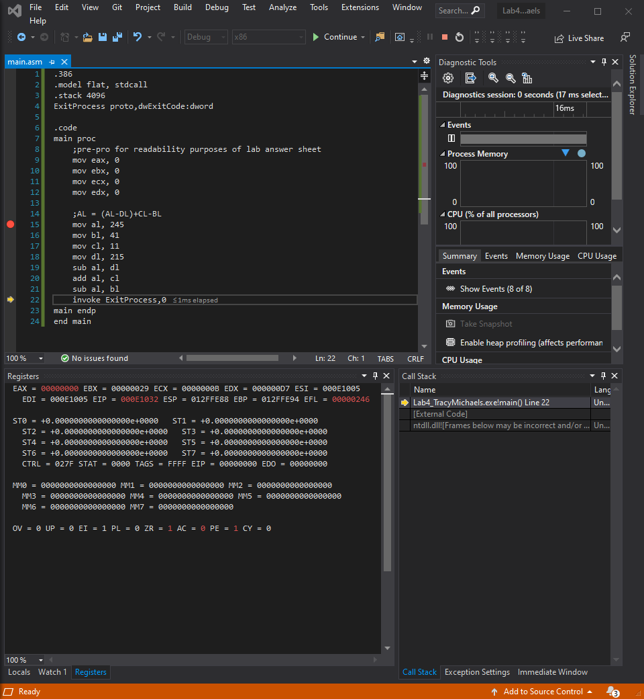

Explanation: subtract the value stored in BL from the value stored in AL and store result in AL (dec 41 – 41) = 0, which is also 0 in hex, also sets zero flag to 1 as final result from calculation is 0